THREATS, ATTACKS AND VULNERABILITIES
Objectives for this domain are:
1. Given a scenario, analyze indicators of compromise and determine the malware
2. Compare and contrast types of attacks
3. Explain threat actor types and attributes
4. Explain penetration testing concepts
5. Explain Vulnerability scanning concepts
6. Explain the imapct associated with types of vulnerabilities
[1:Analyze Indicators of compromise:]
1.1 TYPES OF MALWARE
Number one tool thats being use in most modern cyber attacks is malware.
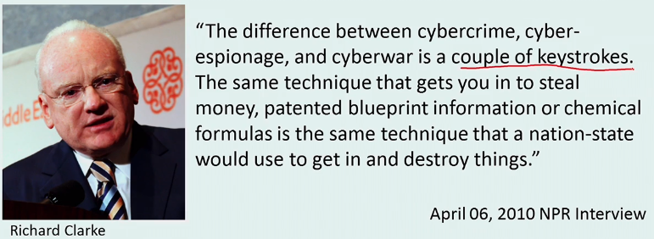
Malware which is short for malicious software is script or code designed to disrupt computer operation, gather sensitive information or gain unauthorized access to computer systems without consent.
Malware characteristics:
-Transparent - not wanna be caught or seen - operates in background (ransomware until it encrypts everything is hidden, after that it comes to front to inform you that your system has been compromised)
-Designed to exploit OS or software vulnerability - we want to have OS patched
-OS and device agnostic - MAC OR LINUX SYSTEMS ARE NOT SAFE!
-Activates programatically - manual with instructions embedded into its structure or calling back to instruction center over the internet
-Responds to commands - commands embedded or coming from control center
-Often evades scanning - does not want to be caught!
Malware Families:
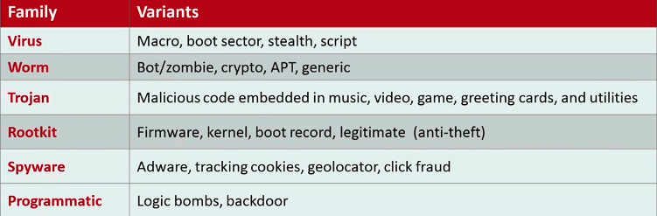
They are based on different behaviour and different camouflage.
VIRUS
Malicious code whose primary function is to replicate and deliver payload:
.Requires user intervention
.Requires host to execute and replicate - has to attach to existing file, cant live on their own
File types: .bat .com .doc .docx .dll .exe .html .mdb .pdf .vbs .xls .xlsx .zip
4 types of VIRUSES:
1. Boot sector viruses - Infects boot(first) sector of a drive, loads into memory upon boot
2. File infector - Infects .com or .exe files by overwriting original code, can easily infect other executables with same extension
3. Companion - Disguises as a legitimate program but uses a different extension with a higher priority
4. Macro virus - Written in a macro language and is platform-independent, infects and replicates templates and documents
How viruses act:
1. Stealth virus - Hides by encrypting its code. Masquerades as the original file and reports that the original file is still intact
2. Memory resident - Upon execution stays resident in memory, can affect other programs that are executing.
3. Armored - Hides itself by obfuscation or adds confusing or unnecesary code
4. Polymorphic - Produces varied but operational copies of itself
5. Metamorphic - Capable of recompiling itself into a new form
WORMS
Malicious code that exploits known vulnerabilities
.Self replicating
.Takes advantage of network transport features to spread (email attachments, messages, network connections especially ports)
4 types of WORMS:
1. Crypto variant [Ransomware] - Encrypts files and demands ransom for decryption key
2. Command & Control [C&C] - Provides subsequent access for the attacker, allows attacker to maintain control capabilities
3. Advanced persistent threat [APT] - Sophisticated, slow and stealthy with c&c capabilities
4. Bot [zombie] - Automated processes that either listen to instructions or have them embedded inside
TROJAN
Malicious code disguised as legitimate application (malicious code gets embedded in music, video, greeting card...)
.Spread trough user interaction
4 types of TROJANS:
1. RAT - Remote access trojan, objective is privileged remote administration
2. Backdoor - Used to open a less obvious connection for later access
3. Downloader - Used to download additional malicious code
4. Keylogger - Captures keystrokes and mouse/pad movements
ROOTKIT
Malicious code designed to allow remote use or root administrator access.
.Embedded in software or hardware
.Very difficult to remove
5 types of ROOTKITS:
1. Firmware - Embedded device firmware
2. Kernel - Embedded in the operating system
3. Persistent - Enabled when the system starts up and shuts down when the system is shut down
4. Application - Runs in current system memory when the specific application is launched
5. Library - Found in software applications that use code libraries such as .dll .so .a ...
SPYWARE
Code that is designed to disrupt your privacy and to collect information without consent.
.Can be used to manipulate configuration settings
.Spreads trough user interaction
5 types of SPYWARE:
1. Keylogger - Captures keystrokes and mouse/pad movements
2. Monitors - Used for tracking user activities
3. Adware - Used for delivering targeted advertising based on user activity
4. Tracking cookies - Used to log web browsing history
5. Click fraud - Automated script that imitates a legitimate user activity by clicking ad for purpose of generating pay per click revenue
PROGRAMMATIC
Malicious code that is inserted by the programmer or publisher when the program was designed or distributed
2 types of PROGRAMMATIC MALWARE:
1. Backdoor - Code designed to bypass access controls
2. Logic Bomb - Code designed to execute when certain event occurs and/or after a certain period of time
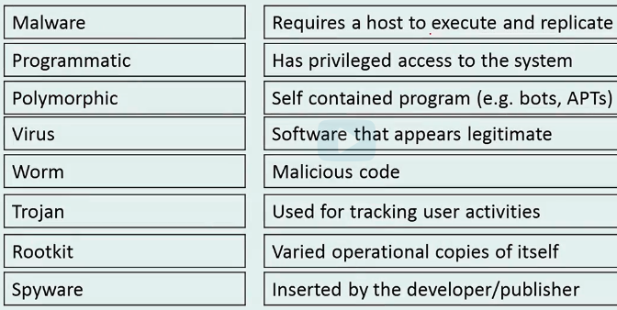
1.2 INDICATORS OF COMPROMISE
Malware use cases:
- Facilitate extortion schemes - ransomware
- Weaponize computers and devices - Bots
- Collect authentication credentials
- Exfiltrate data and intellectual property - Spyware
- Distribute SPAM...
- Carry out information warfare or sabotage
An indicator of compromise is a specific artifact of a virus execution, that with a high degree of confidence indicates an intrusion. (virus signature, IP address, malicious URL, command and control connection, file changes...)
Malware doesnt like to leave these traces and will try to leave as little as possible traces of existing.
Converesly, extortion attacks such as Ransomware and Adaware are attention grabbing.
WannaCry Malware TEST FOR CHALLENGE.
How does malware operate:
- Exploit - persistent by adding executable path in the registry
- Masquerade - Elevate itself to another porcess so that it cannot be easilt found
- Polymorphism - deter the process of analysis by rapidly changing its code signature
- Callback - connections to c&c
- Accomplish task - for example data exfiltration or zombie/bot
- Exit - Once its done it may delete itself or install custom artifacts to confuse analysis
Anti-Virus software is used to identify, contain and in some cases eliminate known malicious code.
- AV software relies on virus detection files(known as DAT files) to identify malware. The definition files must be continually updated by software developer.
- Best practices recommend using more than one type of AV in the enterprise.
Anti-Malware software identifies infections caused by a pantheon of malware including all types of malware.
MALWARE DETECTION & ANALYSIS TECHNIQUES
1. AV and anti-malware software - ^^^
2. Post-infection scanner - 2. gen AV - MalwareBytes
3. Log analysis - Logging all the activity happening - connections, files sent, processes...
4. Malware intelligence - Learning about infection characteristics and compare it to your logs.
5. Malware verification - Analysis of suspicious files and url's - VirusTotal
6. Reverse engineering - Process of analyzing and understanding characteristics: Behavioral/Code analysis
MALWARE ERADICTION TECHNIQUES
1. AV and anti-malware software - Disinfection, quarantine and deletion capabilities
2. Specialized software - eg. Microsoft malicious software removal tool, HijackThis, MalwareBytes
3. Regedit command - Windows registry editor
4. Bootrec - Windows boot sector repair tool - Windows Recovery Environment
5. Bootable software - eg. Microsoft Sysinternals Rootkit Revealer, chrootkit
6. Restoration - Reimage / Rebuild systems
7. Disposal - Remove, sanitize and securely dispose of infected software
- Best bet is disposal - taking the hard disk out, sanitizing it and reinstalling it again
EXAM:
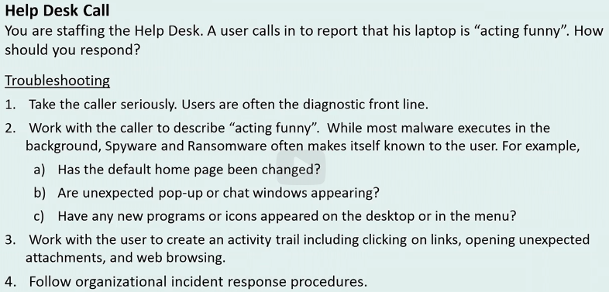
→ Malware use cases
→ Malware detection, analysis and eradication techniques
1.3 SECURITY IN ACTION: MALWARE IOC
https://www.virustotal.com/en/statistics
^ most popular virus analysis service
When a file is submited, a lot of AV programs start scanning the provided file and return the output to us.
That way we can check output of multiple AV DAT files.

